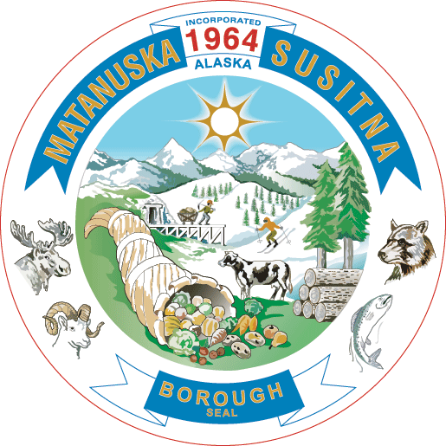

**Matanuska-Susitna Borough**

**Public Works Department**

**Project Management Division**

350 E. Dahlia Avenue • Palmer, AK 99645 (mailing address)

533 E. Fireweed Avenue • Palmer, AK 99645 (physical address)

Phone (907) 861-7723

Letter of Non – Objection and Release of Claims

The letter of non-objection is presented to the Matanuska-Susitna Borough and it’s contractors to enter onto portions of my property for the purpose of:

In exchange for the work performed, I hereby release all claims against the Matanuska-Susitna Borough and further agree that I will hold the Borough harmless from any water related issues as a result of the proposed activity. The Borough (and/or its contractor) is performing this activity with my direct input and participation on the scope of activities and design.

This letter of Non-Objection expires on: ____________________________

Date

__________________________________________

Printed Name

__________________________________________

Signature

__________________________________________

Date